Lines
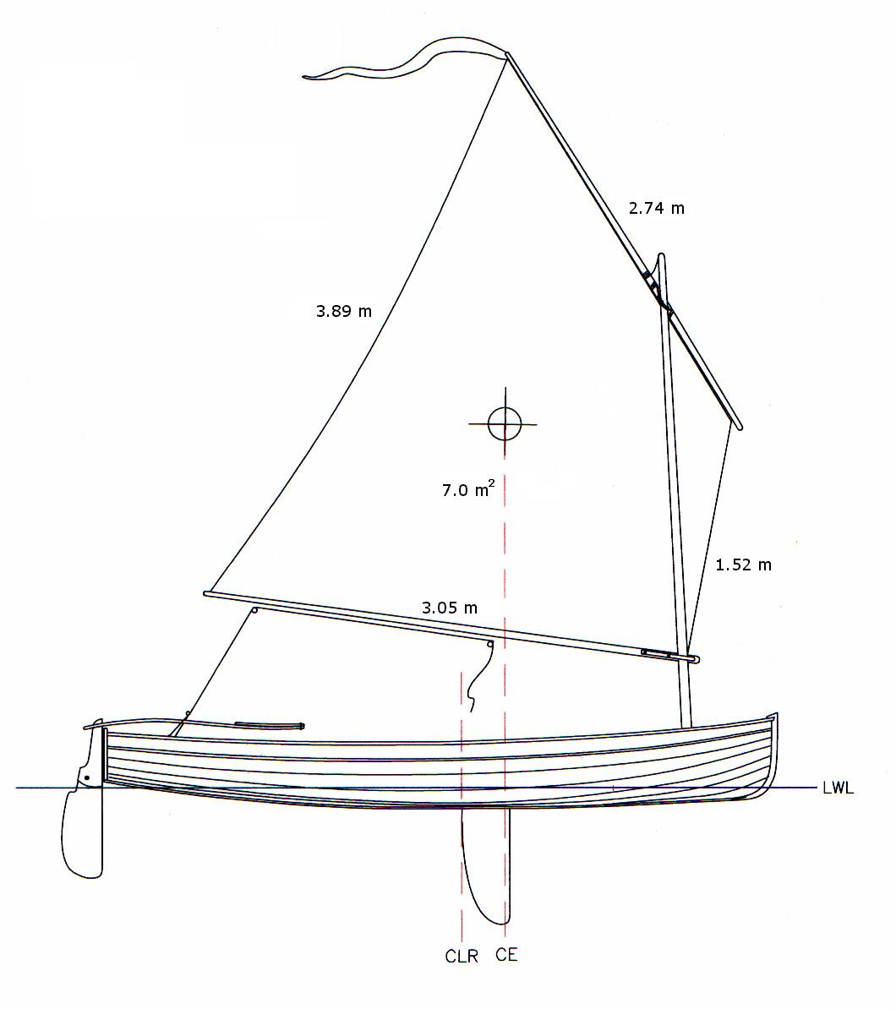 |  | 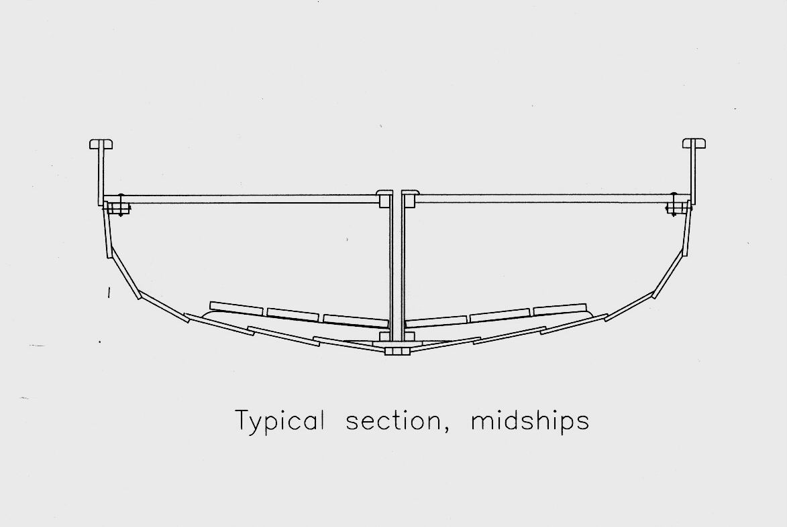

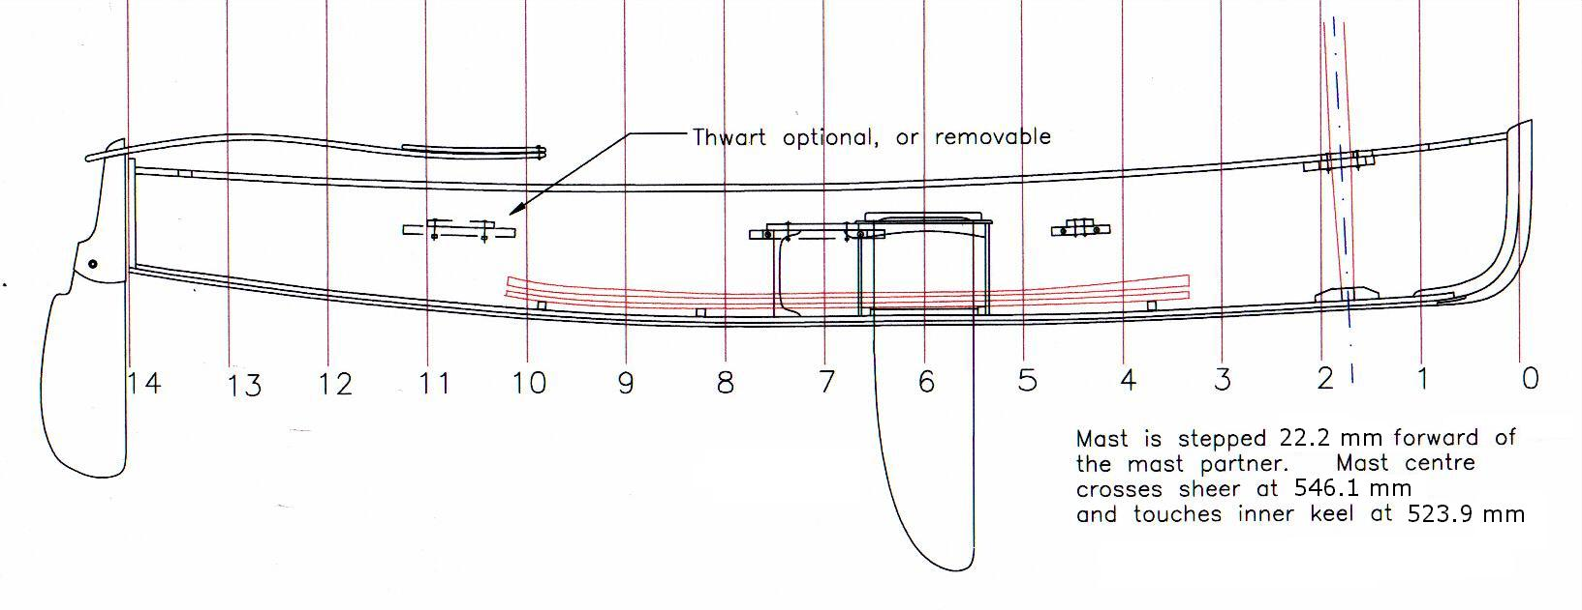

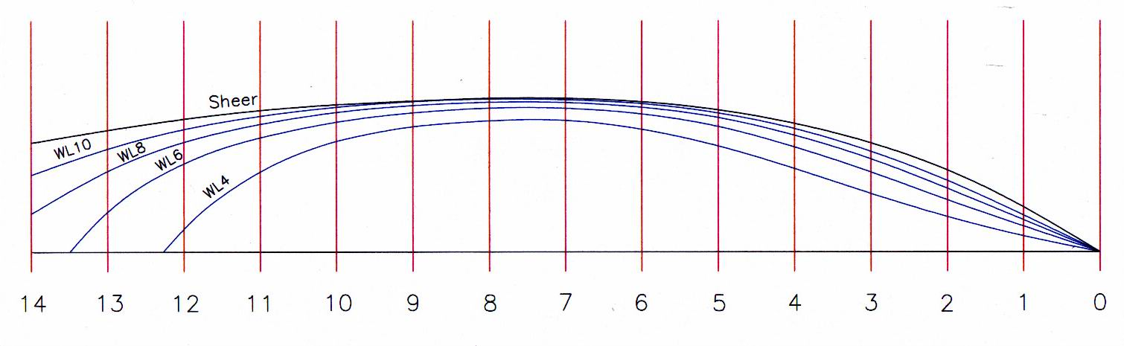

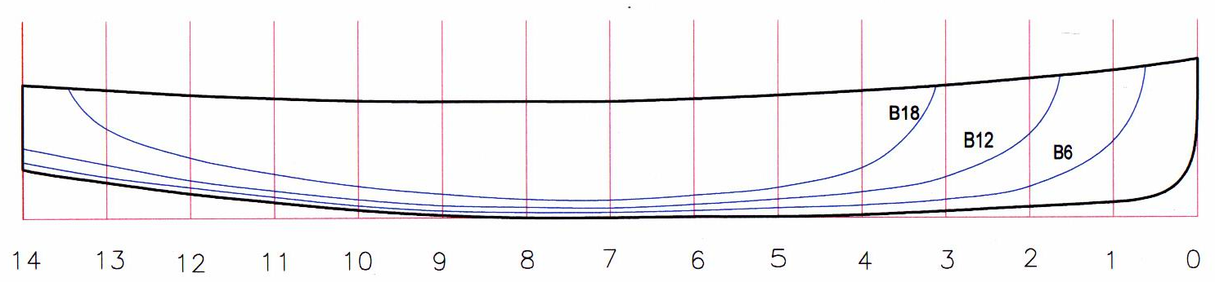

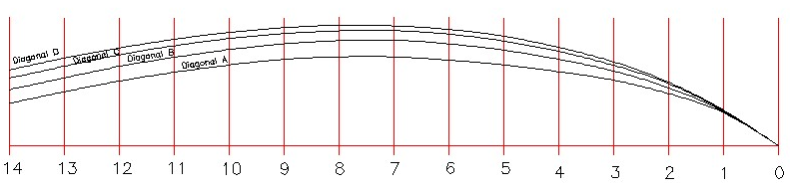

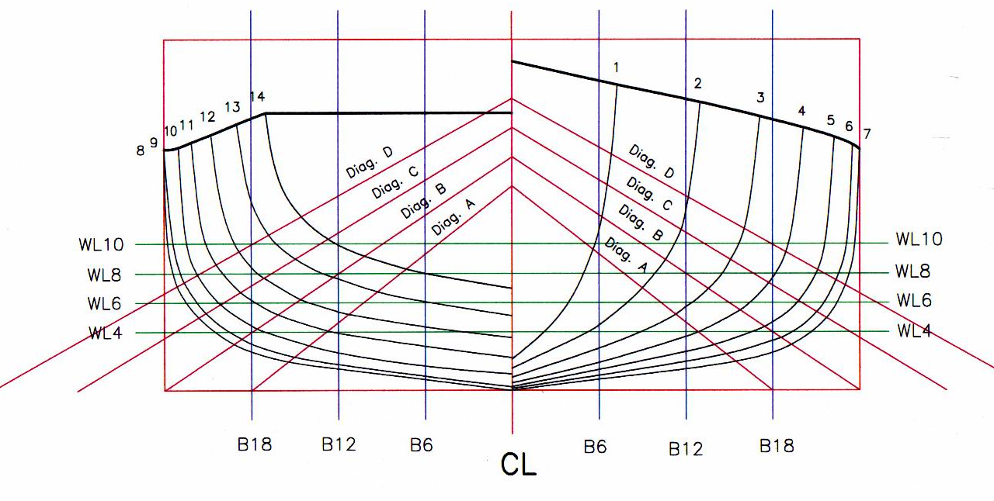

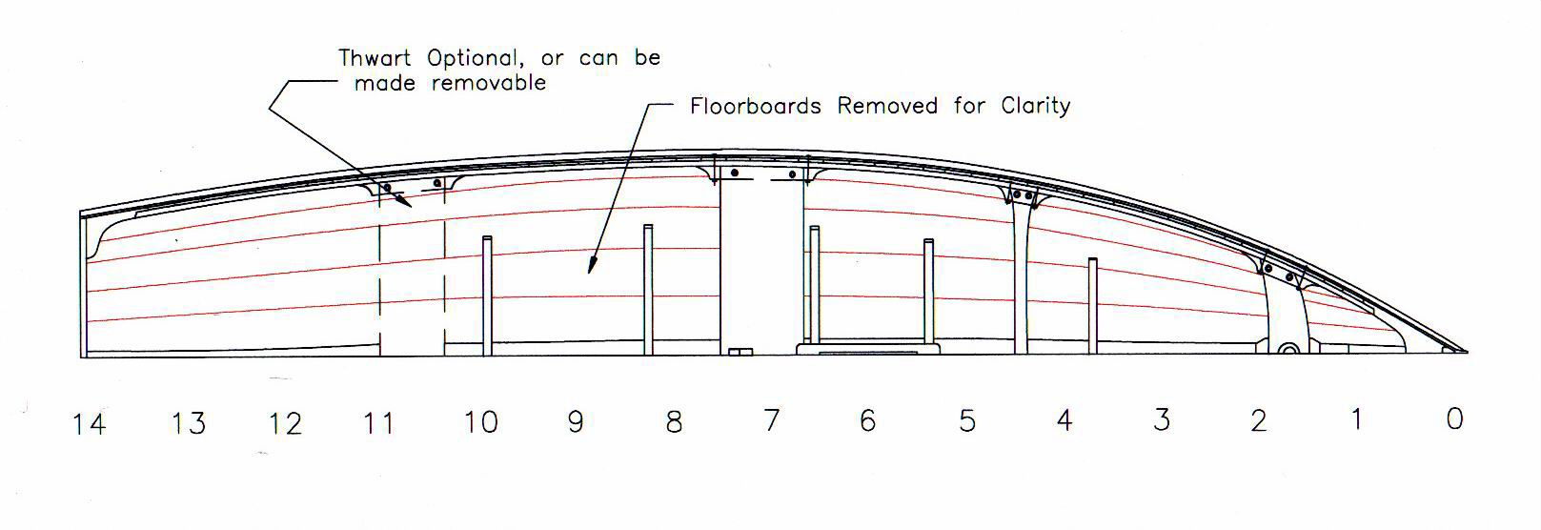

Offsets

** Offsets in millimeters to the inside of the planking **

Heights above baseline
Buttocks spaced at 152.4 mm intervals from CL

STA | Sheer | Butt18 | Butt12 | Butt6 | Keel
0 | 565 | - | - | - | 279
1 | 530 | - | - | 276 | 054
2 | 502 | - | 302 | 111 | 038
3 | 476 | - | 146 | 070 | 022
4 | 457 | 194 | 092 | 045 | 013
5 | 441 | 118 | 067 | 035 | 006
6 | 429 | 086 | 048 | 025 | 003
7 | 422 | 064 | 035 | 019 | 000
8 | 419 | 067 | 038 | 019 | 000
9 | 419 | 086 | 045 | 026 | 007
10 | 426 | 114 | 067 | 045 | 029
11 | 432 | 159 | 098 | 076 | 057
12 | 441 | 219 | 137 | 111 | 092
13 | 460 | 324 | 194 | 149 | 130
14 | 483 | - | 254 | 203 | 178

Halfbreadths from CL
Waterlines spaced at 50.8 mm intervals, starting 101.6 mm above baseline at WL4

STA | Sheer | WL10 | WL8 | WL6 | WL4
0 | 000 | - | - | - | -
1 | 184 | 146 | 124 | 098 | 057
2 | 330 | 279 | 254 | 200 | 133
3 | 435 | 400 | 372 | 311 | 229
4 | 511 | 492 | 464 | 419 | 324
5 | 565 | 553 | 527 | 499 | 422
6 | 597 | 587 | 568 | 549 | 495
7 | 610 | 606 | 591 | 572 | 524
8 | 610 | 606 | 594 | 572 | 521
9 | 597 | 597 | 581 | 553 | 486
10 | 584 | 575 | 553 | 518 | 422
11 | 562 | 540 | 502 | 448 | 302
12 | 527 | 489 | 422 | 333 | 083
13 | 483 | 413 | 305 | 140 | -
14 | 432 | 346 | 479 | - | -

Diagonals
Diag. A – 355.6 mm up on CL, 457.2 mm out on baseline
Diag. B – 406.4 mm up on CL, 609.6 mm out on baseline
Diag. C – 457.2 mm up on CL, 762.0 mm out on baseline
Diag. D – 508.0 mm up on CL, 914.4 mm out on baseline

STA | Diag. A | Diag. B | Diag. C | Diag.D
0 | - | - | - | -
1 | 181 | 191 | 194 | 200
2 | 289 | 324 | 346 | 352
3 | 365 | 416 | 448 | 467
4 | 413 | 483 | 527 | 549
5 | 451 | 533 | 587 | 613
6 | 476 | 568 | 622 | 651
7 | 499 | 591 | 645 | 667
8 | 495 | 587 | 641 | 673
9 | 483 | 568 | 626 | 657
10 | 451 | 537 | 597 | 632
11 | 410 | 492 | 556 | 594
12 | 362 | 445 | 508 | 546
13 | 299 | 378 | 441 | 489
14 | 235 | 311 | 375 | 422

